Presentation Techniques – Why should we bother?
A. Richter
Institute of Environmental Physics, University of Bremen,
P.O. BOX 330440, D-28334 Bremen, Germany
richter@iup.physik.uni-bremen.de
Abstract
In this paper, an uncritical review is given of the pros and cons of joining in on the seminar in presentation techniques at the University of Bremen. This manuscript is intended to be used as template for the extended abstract you have to prepare from your talks. It should be about 4 pages long including figures and references.
Introduction
Giving presentations back home or at international conferences is an important part of the work of a scientist. It is not enough to do excellent work in the lab or at the computer, but the results need also to be brought to the attention of other scientists working in the field. One way of doing this is by presenting ones work at a conference, either in an oral presentation or with a poster. To make the best of such an opportunity, one should practice the talk in advance with a friendly but critical audience. This is best done at the home institute, an example of which is shown in Fig. 1.

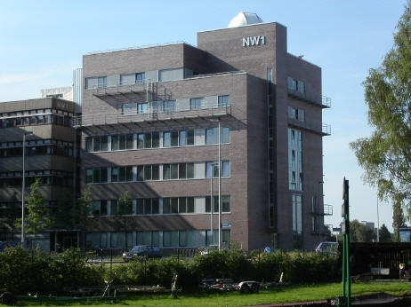
Figure 1: The new building or the Institute of Environmental Physics at the University of Bremen. Please note the blue sky which was not added with Photoshop or other image processing software but sometimes can be observed even in Bremen. Picture courtesy of W. Gurlit, IUP Bremen.
The Seminar
Here comes the main part of your text ...
Summary
As has been shown in this paper, you can fill a whole page of your abstract with very little content in a short period of time. However, you still will have to come up with some really interesting things on the remaining three pages or else your extended abstract will not be accepted.
References
PEP programme at the University of Bremen, lecture material for the seminar on presentation techniques, http://www.pep.uni-bremen.de/services/lectures/winter_2007/Richter/presentation_techniques_WS2007-08.html .
Richard P. Wayne, Chemistry of Atmospheres, Oxford University Press, 2nd. Edition, 44-49 (1991).

